Group Name : CODERS

**Project Name :School Management System**

Group No :13

Project No :P005

Section :13

Shahriar Islam Nafis [2024-1-60-264]

MD Sirajul Islam [2024-1-60-291]

MD Sabir Islam [2023-3-60-553]

Md.Sakib Husen[2022-1-60-274]

Submitted to

Md Sabbir Hossain

**UML Diagram**

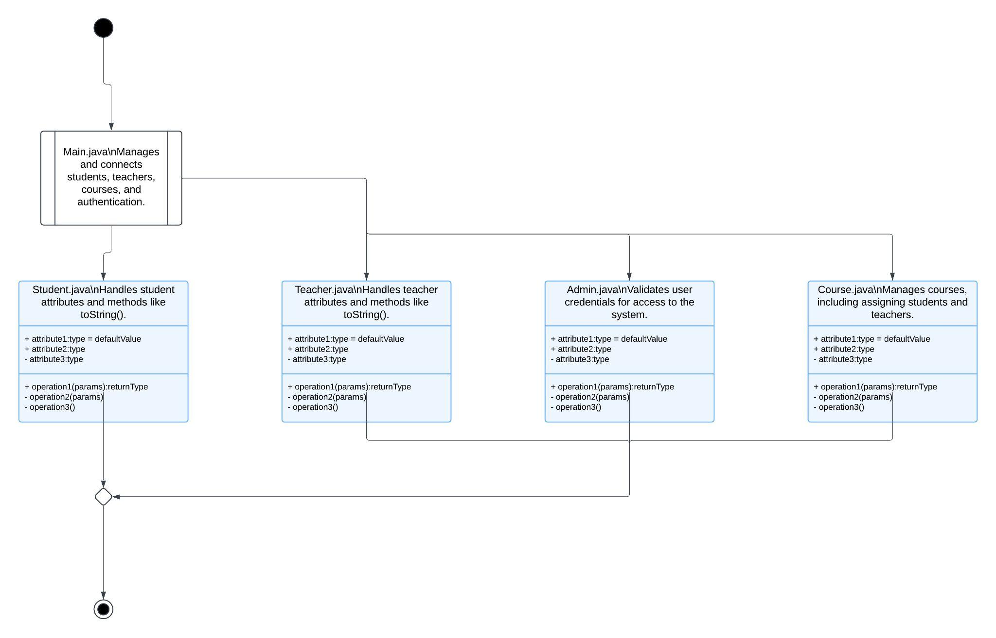

**Project Description: School Management System**

**Project Overview**

The **School Management System** is a Java-based console application designed to streamline the management of students, teachers, and courses in an educational institution. The application provides an intuitive interface for administrators, teachers, and students, each with role-specific functionalities. This system aims to improve organization, simplify course management, and enhance the overall efficiency of school operations.

**Key Features**

1. **User Authentication and Role-Based Access Control**
   * Users must log in with valid credentials.
   * Three roles are supported:
     + **Admin**: Can manage students, teachers, and courses.
     + **Teacher**: Can view assigned courses.
     + **Student**: Can view enrolled courses.
2. **Student Management (Admin Role)**
   * Add new students by entering their name and age.
   * Display the list of all registered students.
3. **Teacher Management (Admin Role)**
   * Add new teachers by entering their name and subject.
   * Display the list of all registered teachers.
4. **Course Management (Admin Role)**
   * Add new courses.
   * Display the list of all available courses.
   * Assign students and teachers to courses.
5. **Course Assignment and Viewing**
   * **Teachers** can view courses they are assigned to.
   * **Students** can view courses they are enrolled in.
6. **Data Display**
   * Comprehensive display of all students, teachers, and courses, including assigned students and teachers for each course.

**User Roles and Functionalities**

1. **Admin**
   * Manage students (add and display students).
   * Manage teachers (add and display teachers).
   * Manage courses (add courses, display courses, assign students and teachers to courses).
2. **Teacher**
   * View the list of courses they are assigned to.
3. **Student**
   * View the list of courses they are enrolled in.

**Technologies Used**

* **Programming Language**: Java
* **Data Structures**:
  + ArrayList for storing students, teachers, and courses.
  + HashMap for storing user credentials.
* **I/O Handling**: Java Scanner for input and console output.

**System Workflow**

1. Upon starting the system, the user is prompted to log in.
2. Based on the logged-in user's role:
   * **Admin** can manage students, teachers, and courses through a menu-driven interface.
   * **Teachers** can view a list of their assigned courses.
   * **Students** can view a list of their enrolled courses.
3. The admin can assign teachers and students to courses, ensuring proper record-keeping.
4. Users can log out, and the system exits gracefully.

**Future Enhancements**

* Implement persistent storage using a file or database.
* Add advanced search and filter functionalities.
* Improve the user interface by migrating to a graphical user interface (GUI).
* Introduce grading and performance tracking for students.
* Enable teachers to add and manage assignments for their courses.

**Conclusion**

The **School Management System** is a robust, role-based application that provides core functionalities needed for school administration. It is designed to be modular, making it easy to extend and improve. This project serves as an excellent foundation for a full-fledged school management solution.